Head of
Marketing & Communications
Recruitment Pack
Date: May 2023

Welcome letter
Too many of our young people are prevented from finding a job they love by a lack of access to appropriate information, advice and connections; inadequate support to overcome multiple layers of disadvantage; or as a result of discrimination. It is unacceptable that one in 10 young people in the UK are not in education, employment or training (NEET).

Young people from marginalised backgrounds are disproportionately likely to be neither earning nor learning, or underemployed, and their outcomes vary significantly more by region. This has been compounded by the pandemic that caused significant economic and educational disruption. As the economy recovers, the benefits are not being felt equally as long-term youth unemployment remains higher than pre-pandemic. This is the core mission of Youth Futures – to support young people facing disadvantage into the record number of job opportunities that are now available.

Long-term youth unemployment causes long-term scarring effects on the individual and their ability to fulfil their potential in society. This is worsened by the current cost of living crisis that is hitting young people hard - they pay double on essentials like rent and bills, compared to the over-50s. Yet the personal and economic prize for addressing this issue is significant. Supporting young people to secure good quality jobs is a sustainable way to tackle the cost of living crisis. UK GDP could benefit by £38billion by lowering levels of young workers classed as NEETs to German levels, according to our recent research.

We have the opportunity to create a profound change in the way this country supports young people from marginalised backgrounds into employment. Improving employment prospects for all young people is a crucial factor in achieving national productivity gains, reducing the benefits bill, and enhancing health and wellbeing in society.
As the What Works centre for youth employment we take an evidence-led, structural and systems-based approach that recognises the importance of national learnings and local context. In 2021 we launched our Youth Employment Evidence and Gap Map – the world’s largest, quality-checked evidence base on youth employment – that shows the global evidence base on what works to improve youth skills, employment and job quality.

We promote strong coordination and partnership working across government, funders, delivery organisations and employers. Our flagship £16 million Connected Futures Fund aims to address the fragmentation of youth employment and skills delivery in the places that need it most, so that young people furthest from the job market receive consistent high-quality support to address complex needs.

As we enter our fourth year under new leadership we are strengthening our organisation and team. This role will play a crucial part in supporting the organisaiton in achieving its vision, mission and business goals. If you are passionate about creating a better future for young people, we look forward to hearing from you.
Barry Fletcher, CEO

Recruitment pack | 2022 2

About us

Youth Futures Foundation is an independent not-for-profit organisation established in December 2019 to improve employment outcomes for young people from marginalised backgrounds. Youth Futures launched with an initial endowment of £90 million from the Dormant Assets Scheme and, in January 2022, the government announced that we had been allocated a further £20 million.

Identify

Invest

Ignite

Our vision
To create a society where all young people have equitable access to good quality jobs.
This includes:
- equal employment outcomes for young people who face discrimination or disadvantage
- a reduced number of young people outside the labour market or in insecure work
- improved progression pathways for young people

Our mission
To narrow the employment gap by identifying what works and why, investing in evidence generation and innovation, and igniting new ideas that change behaviour and practice.

Our primary beneficiaries are young people aged 14-24 who face at least one personal or systemic barrier to progressing into meaningful work, including:
- ethnic minorities, particularly those most at risk of facing disparities in the labour market (e.g. Pakistani; Bangladeshi; Black; Mixed; Gypsy, Roma and Traveller) And/or: young people legally defined as children in need
- young parents, or those who have a caring responsibility
- economic disadvantage (e.g. eligible for free school meals or living in an area of high deprivation)
- special educational needs or disabilities
- experience of offending
- school exclusion or alternative provision
- experience of homelessness
- a mental health or long-term health condition
- experience of problem substance use

4 Recruitment pack | 2022

Our values

We are bold
We want to disrupt the status quo and transform the youth-employment system

We are always learning
We are evidence-driven, we innovate and we aren’t afraid to fail

We are inclusive
We embrace, celebrate and
champion diversity in all its forms – it’s core to who we are

We are collaborative
We build partnerships and share power to increase the collective impact

We are determined
We are relentless in our pursuit of a better future for all young people

Strategy

Our strategic priorities
We are an ambitious organisation that wants to tackle the root causes of youth unemployment for young people from marginalised backgrounds. To do that, we will focus on three priorities over the next three years:

Changing the youth employment system
1
by working in partnership with organisations, policymakers and young people to address structural and systemic barriers.
2

Creating opportunities with employers
to recruit and retain more young people from marginalised backgrounds.
3

Building capacity with practitioners
to support and train more young people from marginalised backgrounds to be ready for work.

Recruitment Pack | 2022 5

Equity, diversity and inclusion statement
6
Recruitment Pack | 2022

The young people we aim to serve - and the challenges they face - are all unique. We need to build a team that reflects this diversity, is highly skilled and committed.
Our commitment to inclusion across all protected characteristics, experiences and socioeconomic background forms the cornerstone of our work.
We work hard to ensure we have a diverse and inclusive workforce. We use identity-blind software for all our permanent recruitment campaigns to reduce unconscious bias during recruitment. We have flexible working policies which are kept under review and many of the more flexible working practices we adopted during lockdown have been retained. The recruitment of our team around our three hubs of Birmingham, Leeds and London has enabled us to attract a greater diversity of talent than simply focusing recruitment in one city.

In building the Board, the Future Voices Group, and making external appointments to the Grants Committee, we have also ensured our governance and advisory structures contain a broad diversity of background and experience.

Our Equality, Diversity and Inclusion (EDI) group within the staff team has senior management sponsorship and leads the creation of a more broad- based EDI strategy.

We are Disability Confident and have committed to ensuring that we attract, recruit, retain, support and develop disabled people in the workplace. We aim to continually improve and develop our talent attraction and inclusive recruitment practices to be reflective of our organisational behaviours and culture.

We are a Living Wage Employer, as we believe a hard day’s work deserves a fair day’s pay. Our base rate of hourly pay is in line with the London Living Wage.

Finances 2021

Total expenditure in 2021 was £11.7m (2020: £13.8m), which primarily comprised
£8.6m (2020: £11.7m) of grant expenditure committed to grantees and other partners engaged in our delivery and evaluation projects. Many of our programmes are multi-year in nature with cash outflow increasing as the programmes scale up.
As such, cash outflow in 2021 was £10.3m. By the end of 2022, we expect to have embarked on multi-year programmes that in total will utilise 72% (£79m) of our allocated
£110m funding, with further programmes to be launched in 2023.

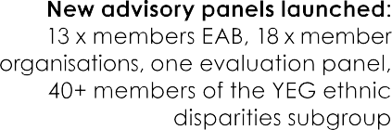
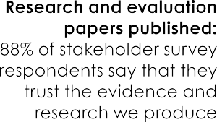

£5.2 million

Grant funding awarded

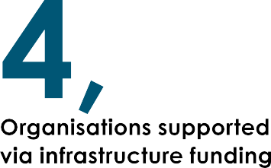

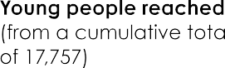
Recruitment Pack | 2022 7

Organisation chart

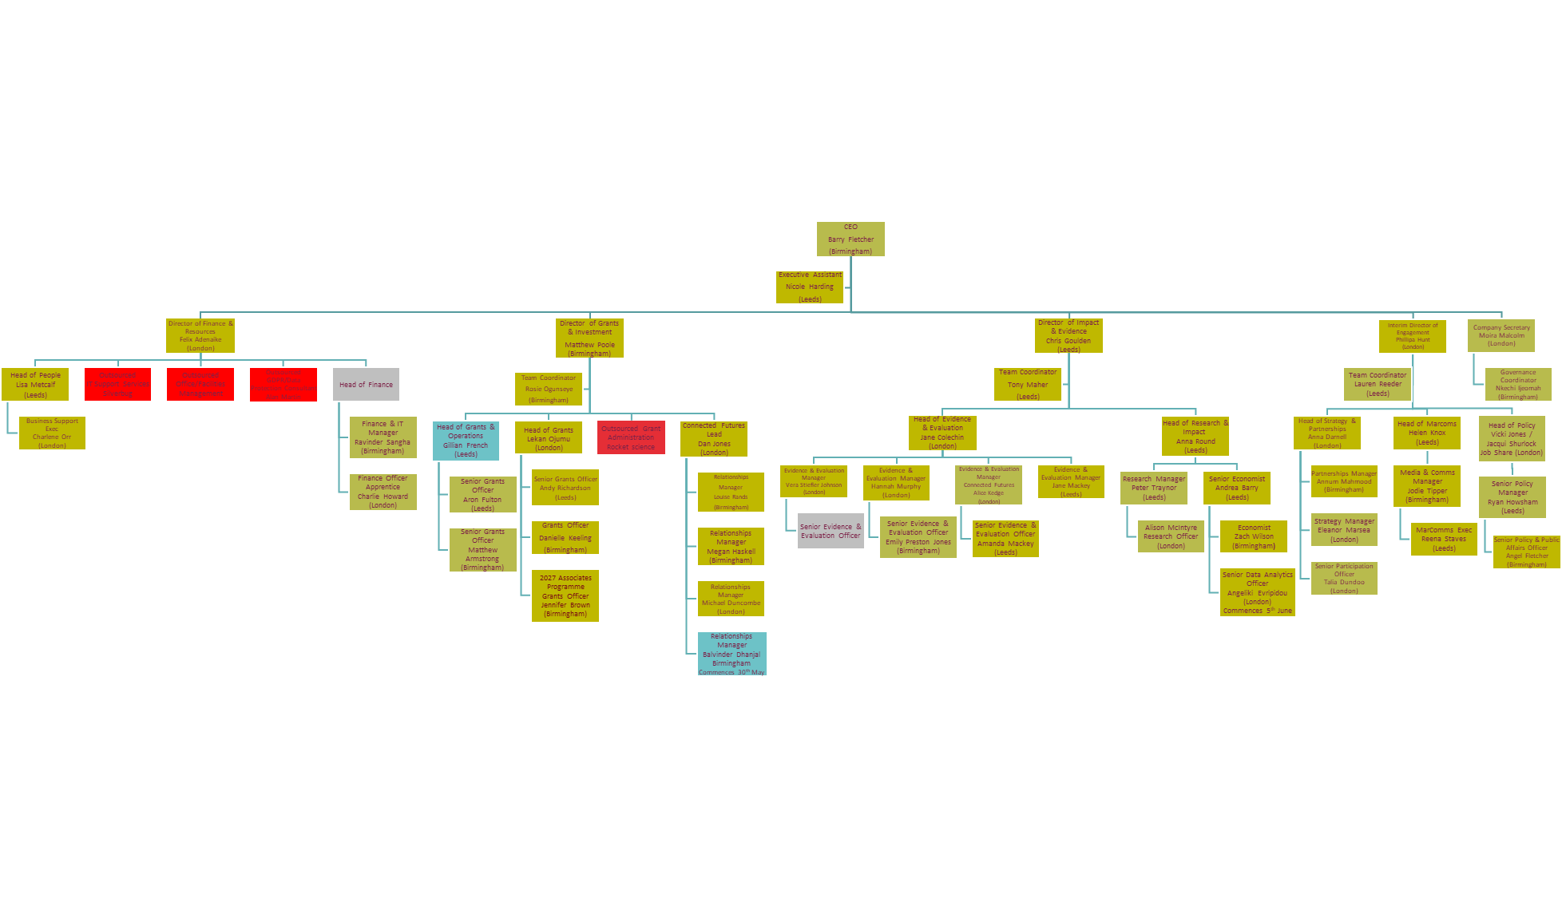

8 Recruitment Pack | 2022

Role description
Role title: Head of Marketing & Communications
Terms: Permanent full time 37.5 hours per week
Location: This role can be based at any of our hubs located in London, Birmingham or Leeds. We currently operate a hybrid model of two-days per week in the office and three-days from home. You must also be prepared to travel to the other hub locations requiring up to four overnight stays per year of 1-2 nights each.
Remuneration: £50,000 to £55,000
Reporting to: Director of Policy and Communications
Direct reports: Media & Communications Manager, Marketing & Communications Executive

We are looking for a talented Head of Marketing and Communications, who working with the Director of Policy and Communications, will create and deliver the organisation’s overall marketing and communications strategy to support Youth Futures to grow its influence and impact.

You will drive our reach with external audiences in support of building the influence and impact of our work and our brand with the audiences that can help change the youth employment landscape for the better. Leading a small team including a Marketing Communications Executive and a Media and Communications Manager, you will create regular, compelling, audience focused content and messaging utilising our research and evaluation outputs and wider work to drive change in youth employment practice and policy. You will leverage the power of existing and new platforms, channels, networks and the advocacy of stakeholders to maximize the marketing and communications potential of our work.

This is a fantastic opportunity to use your imagination and creativity to deliver consistent, compelling marketing and communications activities and campaigns with an ambitious organisation. We are looking for a bold and effective senior marketing and communications professional with the knowledge, experience and skillset to deliver high quality engagement to generate lasting change.

Key responsibilities

- To work closely with the Director of Engagement and wider senior leadership team to establishing Youth Futures as a centre of excellence in youth employment, with young people always front and centre
- To lead all marketing and communications development, ensuring that strategies, campaigns and activities across all departments optimise stakeholder perception of Youth Futures and the impact it is making
- To lead on the creation, testing, evaluation and roll-out of an effective programme of innovative marketing and communications campaigns, ensuring that all test activities (channels, products, audiences, propositions etc) are replicable and scalable.
- To future proof Youth Futures’ marketing programme by building a network of external contacts, undertaking regular stakeholder analysis and sector research, investigating ways to improve effectiveness, seizing opportunities, anticipating risks and encouraging innovation and improvements
- To build and maintain our brand reputation with key external audiences across all platforms covering all key areas of Youth Futrures’ activity
- To take responsibility for the brand, website, events, media, social media, and printed material
- To build, lead, inspire and develop a high performing team, supporting and line-managing two team members to achieve departmental objective

PERSON SPECIFICATION

 | Essential | Desirable
Knowledge, experience and abilities
Considerable proven experience in both marketing and communications and in developing and executing strategies and plans | X
Demonstrable PR experience of establishing strong relationships with the media in order to fulfil YFF’s ambition to become the ‘go to’ for influential comment on the young peoples‘ agenda across TV, Radio, internet and print | X
Experience of developing and delivering innovative marketing and communications campaigns, preferably including events management, alongside multiple stakeholders and partners and able to measure the PR value of these from an influencing perspective | X
Expertise across the breadth of digital marketing | X
Strong relationships with third sector, private sector and youth sector media | X
Proven ability to cost campaigns and other projects, set and track budgets and measure and demonstrate success | X
Experience in managing external contractor and supplier relationships (as a small team some expertise will need to be bought in) | X
Track record in leading, motivating and developing a diverse and high performing Marketing and Communications teams to deliver required results | X
A working knowledge of charity law, compliance and best practice, particularly in the area of data protection, marketing consent and vulnerability. | X
Able to work well with young people acting as Youth Futures Ambassadors and able to work in collaboration with organisations who share values and mission to improve outcomes for young people | X
Ability to apply creative thinking and problem solving to deliver innovation | X
Skills & competencies
Support, coach and develop a team of people who are split across three different locations | X
Exceptional writing and editing skills | X
Expertise in use and application of digital marketing analytics to inform marketing plans and strategies | X
Excellent time management and ability to prioritise, deliver, manage and coordinate a number of projects simultaneously to tight timescales | X
To role model positive leadership attributes that demonstrate alignment with Youth Futures values and behaviours and embed equal opportunities and diversity values and objectives | X
Strong IT skills, including use of MS Office applications (Word, Excel, PowerPoint etc), shared online folders, calendars and contacts and Wordpress and MailChimp | X

MINDSET
- a genuine personal commitment to Youth Futures mission, vision and values
- a willingness to collaborate internally and externally to achieve our mission and apply commitment to Youth Futures Foundation values to everyday working
- to thrive when operating in a growing and evolving organisation
- a proactive and flexible approach
- a positive and can-do attitude, willing to roll sleeves up to get into details where necessary
- Demonstrate inclusiveness, collaboration and respect
- a commitment to equity, diversity and inclusion
- to contribute to and help build a strong team culture
- follow internal policies, processes and practices

THINGS TO KNOW
As part of Youth Futures Foundation’s safeguarding policy, all employees are subject to a basic Disclosure and Barring Service (DBS) check
The young people we aim to serve – and the challenges they face - are all unique. We are looking to build a team that reflects this diversity. Our commitment to inclusion across race, gender, age, class, religion, identity, and experience forms the cornerstone of our work. We are an equal opportunities employer, welcoming applications from all sections of the community.

We are particularly keen to encourage people with lived experience of the challenges facing young people in the labour market, and committed to supporting you in your application. Please contact us if you require any additional support.

Internally, we encourage an open, collaborative and inclusive working environment.

Benefits and General T&C’s

Probationary Period - all offers of employment are subject to a six month probationary period. Regular reviews will be undertaken during this period.

Holiday Year – 1st January to 31st December.

Holiday entitlement – holiday is issued in hours 210 per year equivalent to 28 days holiday, plus 8 statutory bank holidays. Entitlement is pro-rata for part-time employees. Holiday can be requested via the HRIS BreatheHR system. We are also flexible for employees to work on occasional public holidays (except Christmas, Boxing or New Year’s Day) in lieu of taking a day off to celebrate an alternative significant religious day. Please discuss this further with line manager of Head of People.

Hours of work – are as specified within individual contracts of employment. Our standard working hours are 37.5 per week, standard working hours are 9:00am – 5:30pm including one hour lunch.

Lunch break – lunch breaks are a minimum of 30-minutes . Refreshment facilities are provided in each of our hub locations.

Flexible working – we offer a range of different working patterns such as variable start / finish times, part-time or compressed hours. Please speak with your line manager or Head of People to discuss any variation to working pattern or hours. Requests for flexible working can be made informally or formally.

Location – each employee will be given a hub location as their place of work, however there is a requirement to visit or work from other hub locations as necessary, including to attend the periodic face to face, all staff away days (which involve an overnight stay). The hub locations are London, Birmingham and Leeds.

Hybrid working – we currently offer an arrangement that allows you to work three days per week from home. However, if your home working situation or general working preference means that you prefer to work in an office, there is no upper limit to the number of days working in the office. We provide all relevant home office equipment to ensure you are properly equipped to work effectively from home. A catalogue of equipment is offered for you to select the required equipment.

Volunteering days – we offer three paid volunteering days per year, pro-rata for part time employees, unless otherwise agreed at our discretion each year (January to December) to allow employees to undertake voluntary/charitable work. This time can be split into half days. Volunteering time is recorded on the HRIS BreatheHR system.

Personal/professional training allowance – a personal training allowance of £750 is allocated to each employee per year to use in a variety of methods such as conferences, events, books, journals, professional subscriptions/memberships, contribution to qualifications, coaching, to support with CPD, and £250 per head for functional teams to pool and engage in collective training.

Salaries – salaries are paid via BACS direct into bank accounts on the 25th of each month, where the 25th falls on a weekend, payment will be made the Friday before. Payslips are issued electronically via Xero.

Enhanced Maternity, Adoption and Shared Parental Leave Pay - weeks 1 to 26 on full pay, weeks 27 to 39 on Standard Maternity Pay (SMP), weeks 40 to 52 unpaid (eligible at 6 months service).​

Enhanced Paternity/Partner leave - three weeks at full pay.

Absence reporting – employees are expected to contact their line manager and/or Head of People to notify of any absence at your earliest possible opportunity and by no later than 10:00am. Absence is recorded on the HRIS BreatheHR system.

Sickness absence payments – for the first 6 months of service you will receive a maximum of four weeks full pay, after 6 months you may receive up to 12 weeks full pay. After this period the below income protection policy will then apply.

Income protection​ – provides replacement income if an employee is absent from work through long-term illness or injury. After 13 weeks of absence, the income protection plan provides 75% of basic salary for a two-year period. Provided by AIG.

Smart Health – an early support scheme provided as part of the above income protection plan. It provides a range of services and support which are available following one week of absence, to prevent or reduce longer term absences. The scheme provides unlimited access to six Smart Health services, as follows; 24/7 GP service, second medical opinion service, mental health support, a health check, nutrition consultations and an online fitness programme. This is available to all employees and immediate family, including children up to the age of 21

Employee Assistance Programme – A 24-hour helpline with access to a range of legal, consultancy, 24/7 crisis assistance support and signposting. Provided by Assured Health.

Health Cash Benefit – a cash plan insurance policy that helps cover the cost of everyday health care, such as dental, optical and therapies. The plan reimburses some or all of the cost of routine and/or unforeseen healthcare costs and appointments. Full details of entitlements and support available will be issued to you direct from the provider Medicash. Totalling £995/year.

Group Life Assurance​ – a policy which enables employees to provide a tax-free lump sum benefit payment, and/or a longer-term income to their family and dependants in the event of death whilst in Service. Cover provided by Aviva. Payment is based on 4 x basic salary.

Season Ticket Loan – An interest free loan for a 6 month or 12-month season ticket with monthly deductions from salary.

Travel card loan – the company can provide financial support to purchase travel cards. This is then deducted on a monthly basis from salary for an agreed time period.

Pension – There is an auto-enrolment pension scheme provided by People’s Pension. If you meet the auto-enrolment criteria, you will automatically become a member of the scheme. Youth Futures Foundation pay an employer contribution of 6%, with an employee contribution of 5% of salary. An opt in to an additional 2% matched contribution can be made with a contribution totalling 15%. Membership details will be issued to you upon commencement. You can choose to opt out the scheme should you wish.

Cycle to Work Scheme – Provided through the Bike2Work Scheme. https://www.bike2workscheme.co.uk/ Allows you to buy commuter bikes and cycling accessories through us, so you spread the cost and making savings through a tax break. For more information on the scheme and to obtain our company pin to register please speak to our Head of People.

Expenses - Reasonable expenses incurred in line with the Travel & Expense Policy will be reimbursed against receipts. Expenses can be claimed back via the Zoho app.

Dress Code – dress for the day. We expect that you will dress appropriately for the work in which you are carrying out.

10 Recruitment Pack | 2022

How to apply

To apply for the role please visit BeApplied
Recruitment timetable

Deadline for applications: Sunday 11th June 2023 11:59pm

Interviews: W/C 19th June 2023

If you require this document in an alternative format, please contact Lisa Metcalf, Head of People
Lisa.metcalf@youthfuturesfoundation.org

Recruitment

Queries

If you have any questions regarding this vacancy or would like to find out more, please contact Lisa Metcalf, Head of People
Lisa.metcalf@youthfuturesfoundation.org

Recruitment Pack | 2022 11

